**EXPERIMENT-5**

**DATE**: **28-09-2025**

**AIM**: To Create a simple cloud software application for Library book reservation system for SIMATS library using any Cloud Service Provider to demonstrate SaaS

**PROCEDURE**:

**step1**: Go to zoho.com.

**step 2**: Log into the zoho.com.

**step 3**: Select one application step.

**step4**: Enter application name as library book reservation system.

**step 5**: Created new application as library book reservation system.

**step 6**: Select one form

**step 7**: The software has been created.

**IMPLEMENTATION:**

**OUTPUT;**

**1.User Registration**

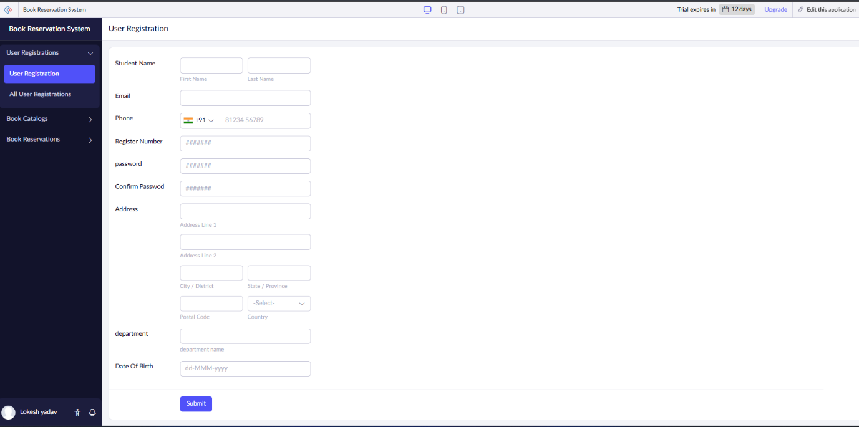

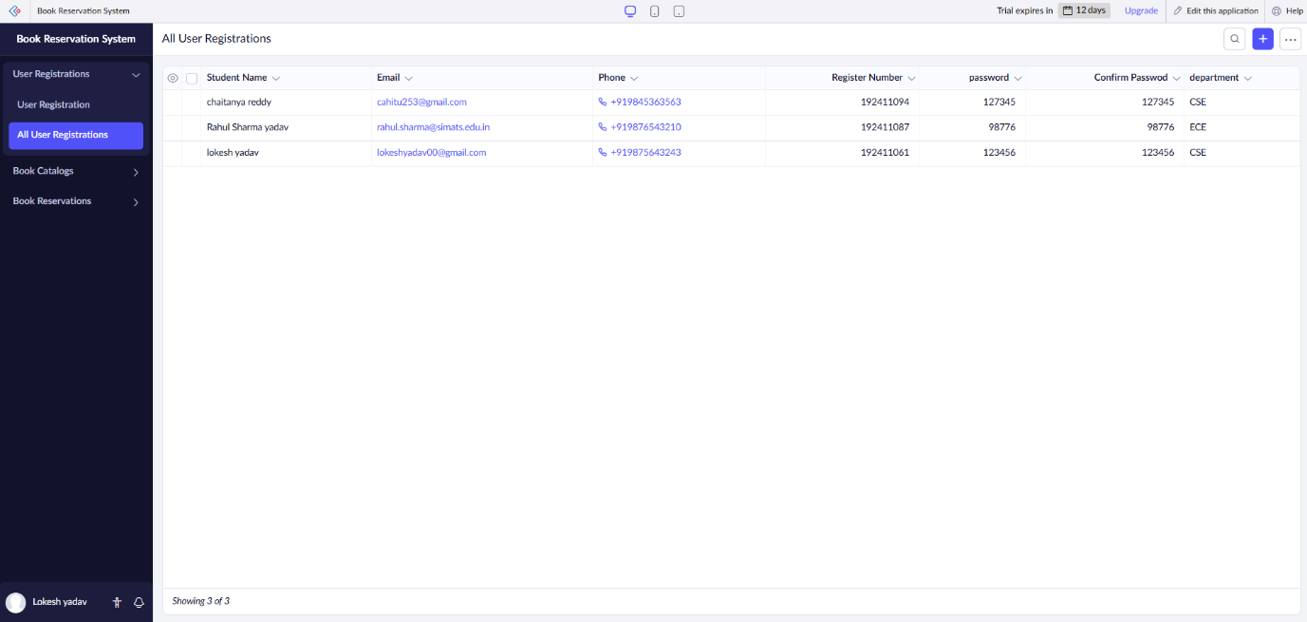

**2.Book Catalog**

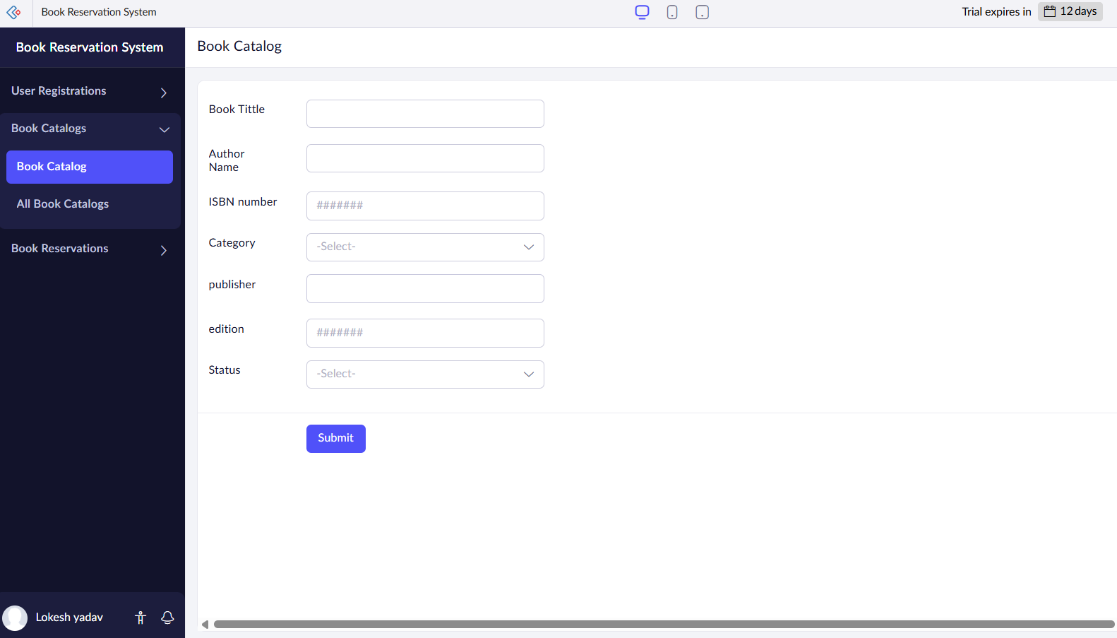

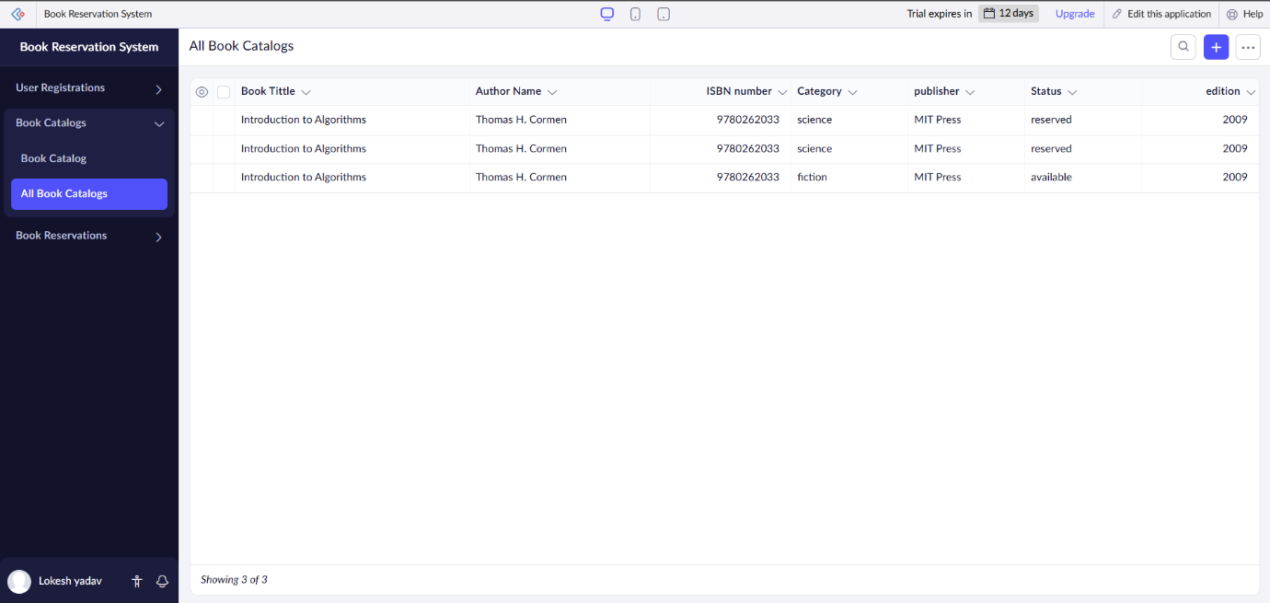

**3.Book Reservation**

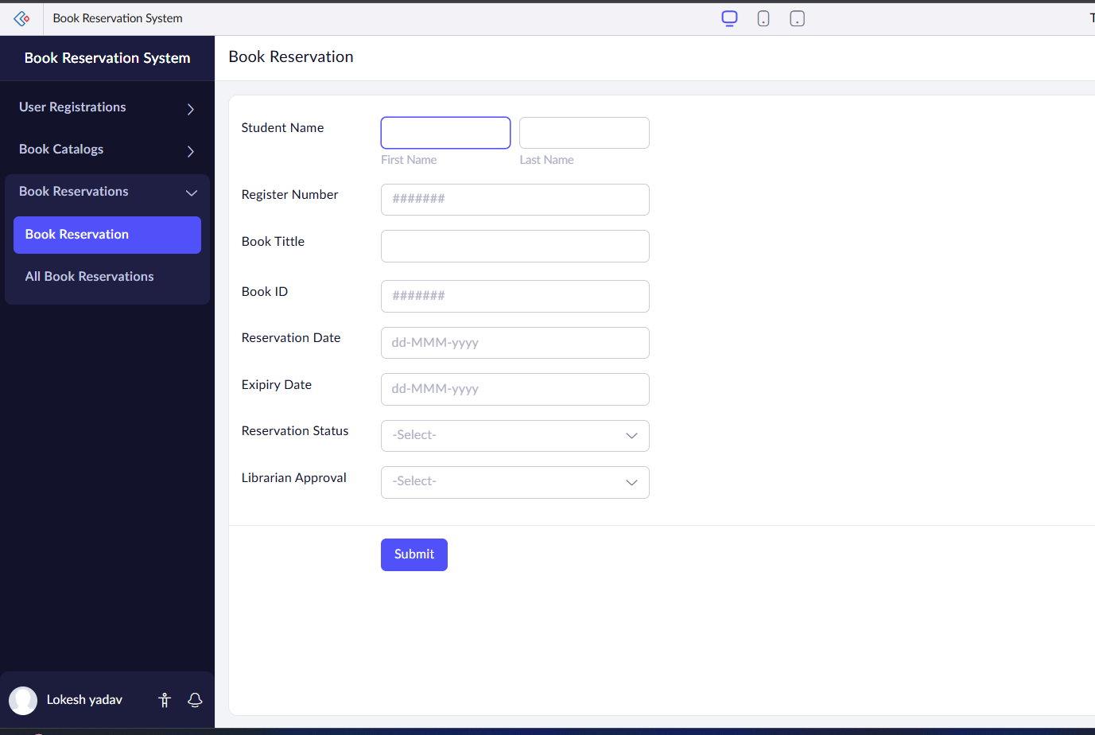

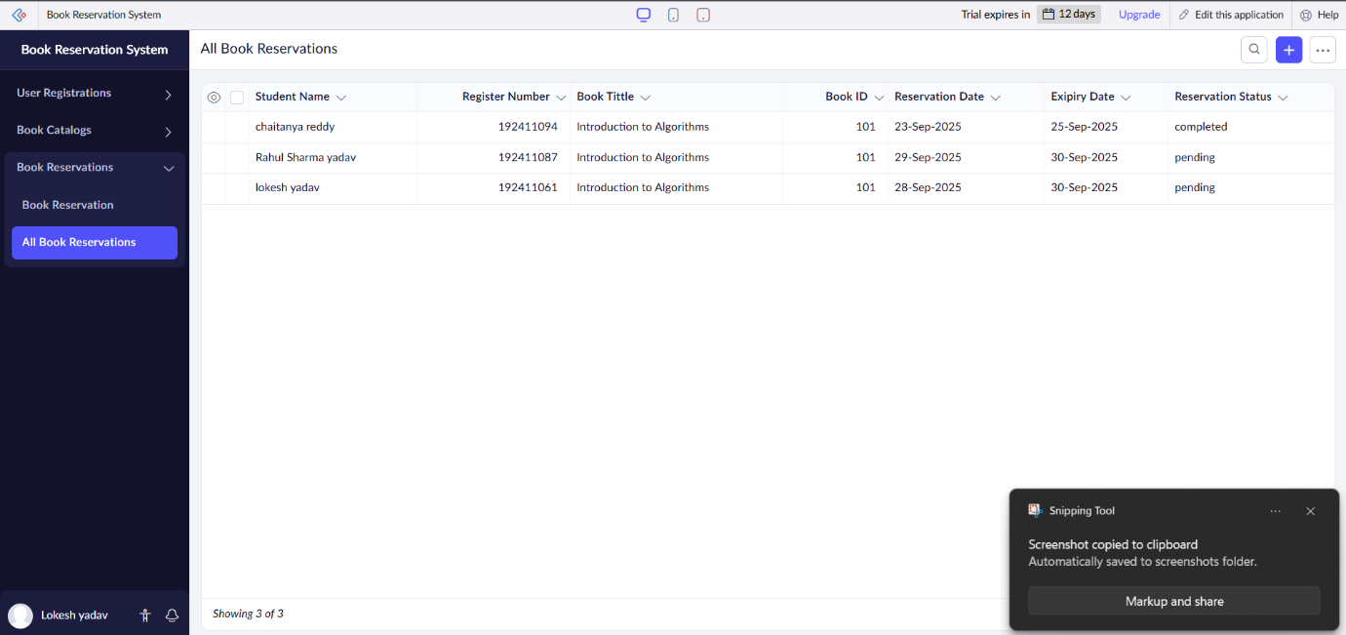

**RESULTS;** successfully implemented the simple cloud software application for Library book reservation system for SIMATS library using any Cloud Service Provider to demonstrate SaaS